Lecture 7
CHEMISTRY OF AMINO ACIDS AND PROTEINS 1

INTRODUCTION
Amino acids are the basic structural units of Proteins. Proteins in all species from bacteria to humans are constructed from the same set of twenty amino acids. Outside the formation of proteins, amino acids are involved in neurotransmitter transport and biosynthesis. An amino acid consists of amino group (NH2), a carboxylic group (-COOH), a hydrogen atom (H) and a distinctive R group which is specific to each amino acid. These 3 groups are bonded to a carbon atom, called the α- carbon. Amino acids take part in many types of reactions, but the most important of these is the formation of a peptide bond. This involves the joining of the α- carboxyl group of one amino acid to the α- amino group of another amino acid, with the loss of a water molecule. Amino acids are grouped according to the nature of their side chains. Since amino acids are weak acids, their strength is expressed as pKa (negative log of ionisation constant). The net charge on an amino acid depends on the pKa of its functional groups and the pH of the surrounding medium.
The isoelectric pH, also called pI is the pH midway between pKa values on either side of the isoionic species.

Chemical Nature of Amino Acids
Amino acids are the basic structural units of proteins. An amino acid consists of amino group, a carboxyl group, a hydrogen atom and a distinctive R group bonded to a carbon atom, called the α- carbon. An R group is referred to as a side chain. Amino acids in solution at neutral pH are predominantly dipolar ions (or Zwitterions) rather than unionised molecules. In the dipolar form, the amino group is protonated (-NH3+) while the carboxyl group is dissociated (-COO-). The ionisation state of an amino acid varies with pH. In acid solution e.g at pH 1, the carboxyl group is un-ionised (-COOH) and the amino group is ionised (-NH3+).
In alkaline solution, the carboxyl group is ionised (-COO-) and the amino group is un-ionised (-NH2). At physiologic pH, carboxyl groups exist almost entirely as -COO- and amino groups predominantly as –-NH3+.

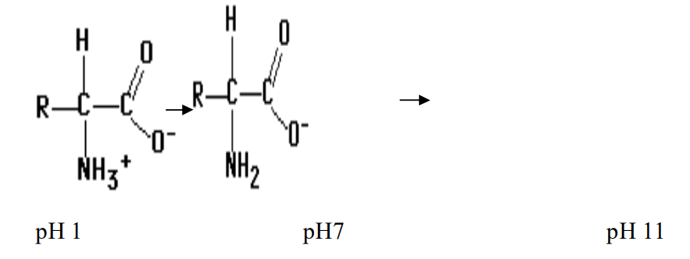
Fig. 1a: Ionization States of an Amino Acid as a Function of pH.
Twenty kinds of side chains varying in size, shape, charge, hydrogen bonding capacity and chemical reactivity are commonly found in proteins. All proteins in all species from bacteria to humans are constructed from the same set of twenty amino acids. The different range of functions mediated by proteins results from the diversity and versatility of these twenty kinds of building blocks. The arrangement of four different groups about the α- carbon confers optical activity on amino acids. The 2 mirror images are called the L-isomer and the D-isomer. However, only L-amino acids are constituents of proteins. D-amino acids that occur naturally include free D-serine and D- aspartate in brain tissue, D-alanine and D-glutamate in the cell walls of gram +ve bacteria and D-amino acids in some non-mammalian peptides and certain anti biotics. Many proteins also contain derived amino acids, which are usually formed by enzymatic modification of an amino acid after it has been incorporated into a protein e.g collagen contains hdroxyproline (the –OH group serves to stabilize the collagen fibre), pro thrombin, a clotting protein contains γ-carboxyglutamate. Defective carboxylation of glutamate in this protein may lead to haemorrhage. The action of some hormones is also mediated by phosphorylation and dephosphorylation of specific serine residues in a variety of proteins.

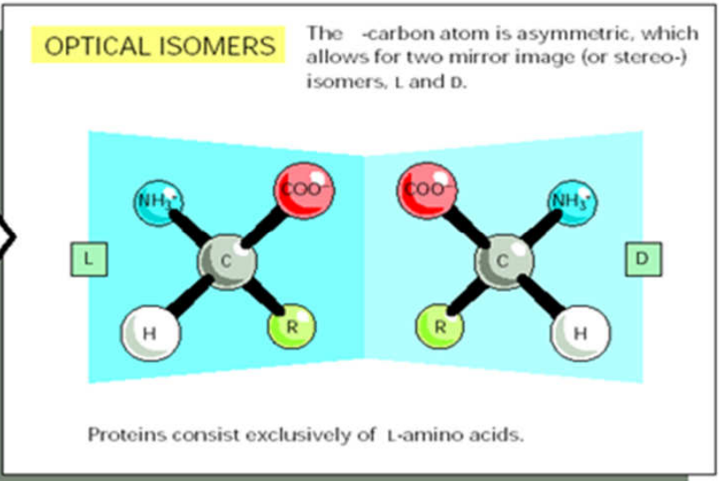
Fig. 1b: Absolute configurations of the L- and D- isomers of amino acids.

The 20 Amino Acids found in Proteins
The simplest amino acid is glycine, which contains a hydrogen atom as side chain. It is the only non-chiral amino acid. Alanine has a methyl group as its side chain. Others that have hydrocarbon side chains include valine, leucine, isoleucine and proline.
Serine and threonine contain aliphatic hydroxyl groups. Aromatic amino acids include Phe, Tyr and Trp. The side chains of these amino acids are uncharged at physiologic pH. Lysine and Arginine contain +vely charged side chains at neutral pH, while His is either +vely charged or neutral depending on its local environment. These 3 are called basic amino acids.
Glu, Asp are called acidic a.as and are –vely charged at physiologic pH. The uncharged derivatives of Glu and asp are glutamine and asparagine. They contain a terminal amide group rather than a carboxylate.
Two amino acids with sulfur containing side chains are methionine and cysteine. Cys plays a special role in some proteins by forming disulfide cross-links.

Table: The 20 Amino Acids.
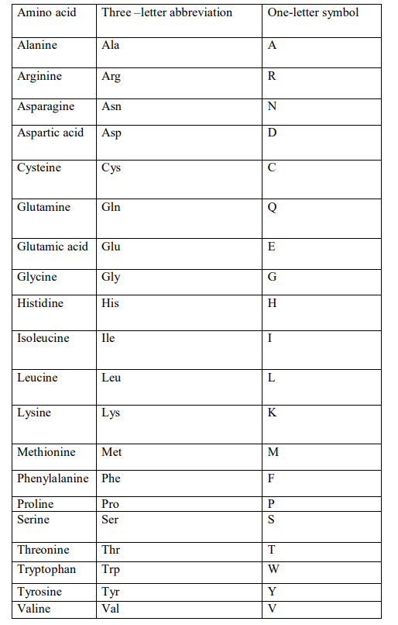
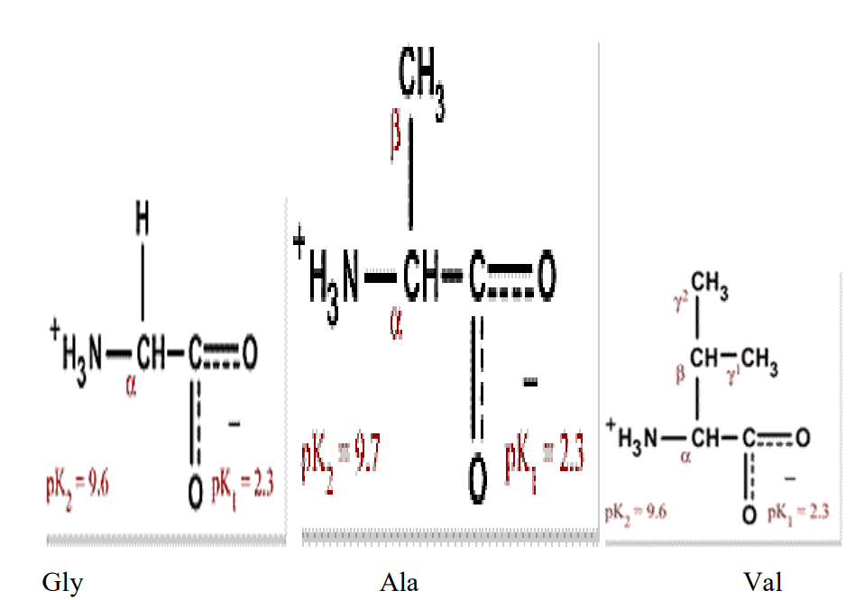

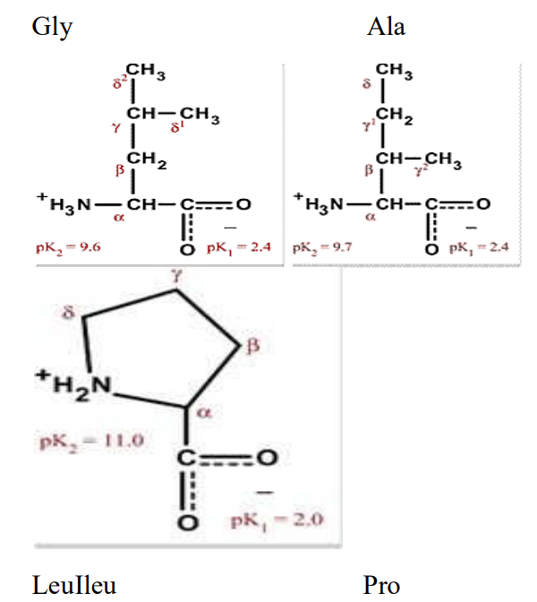

Amino acids with Hydrocarbon side chains.
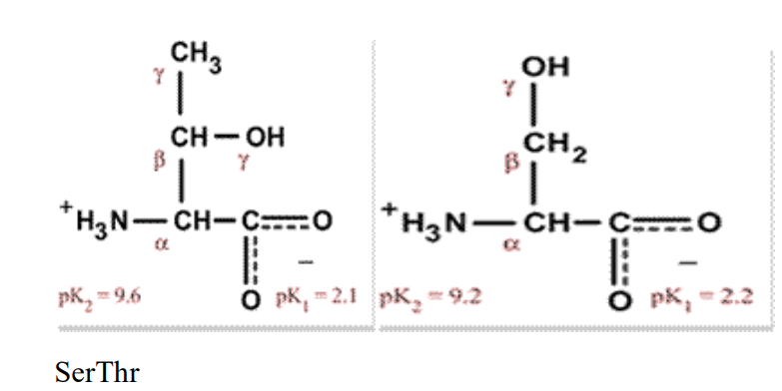
Amino acids with side chains containing hydroxyl (OH) groups.

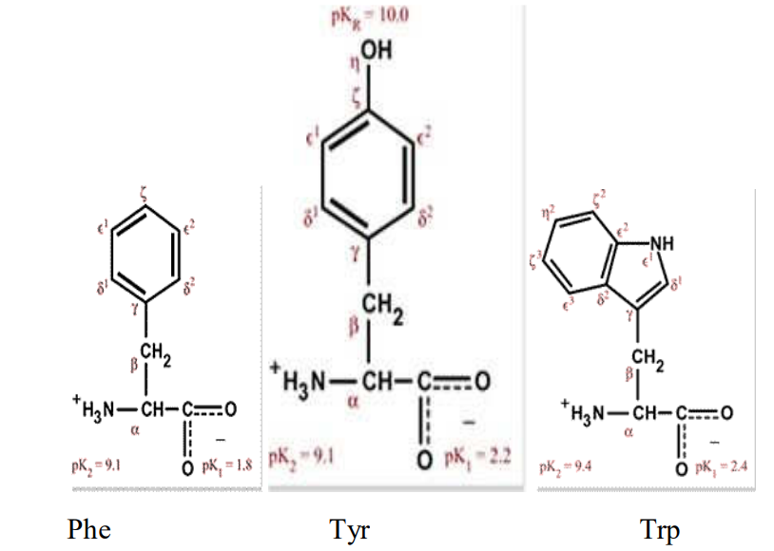

Amino acids with aromatic side chains.

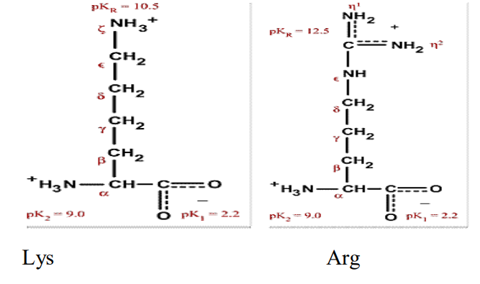
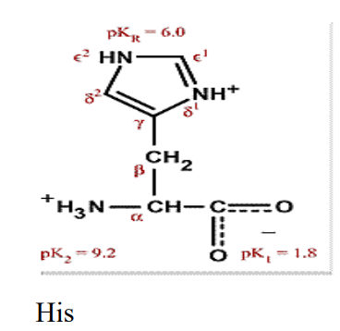

Basic Amino acids.

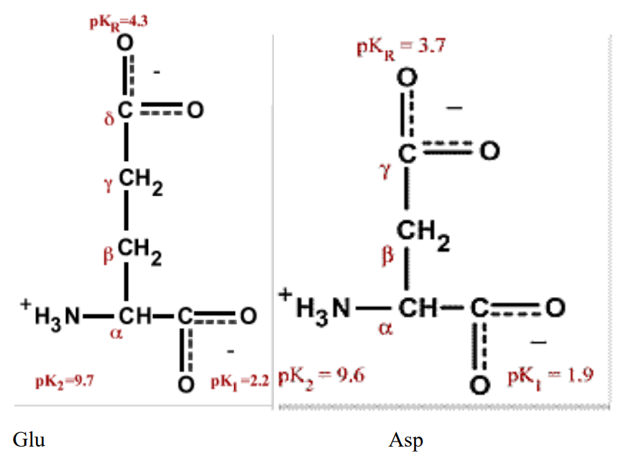
Acidic amino acids.

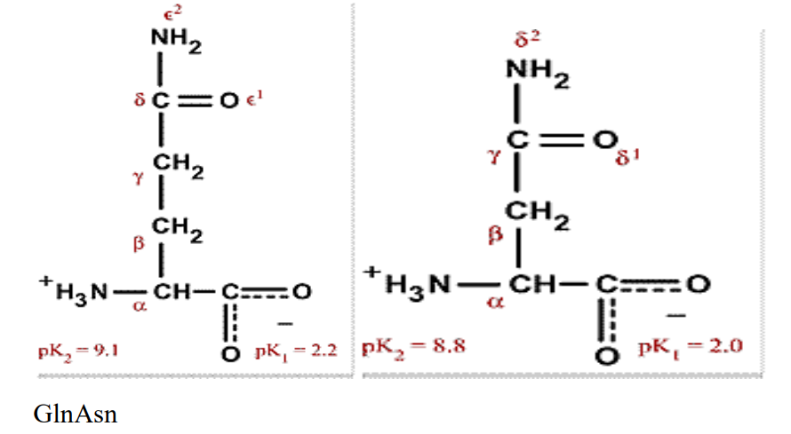

Amino acids with carboxamide groups.
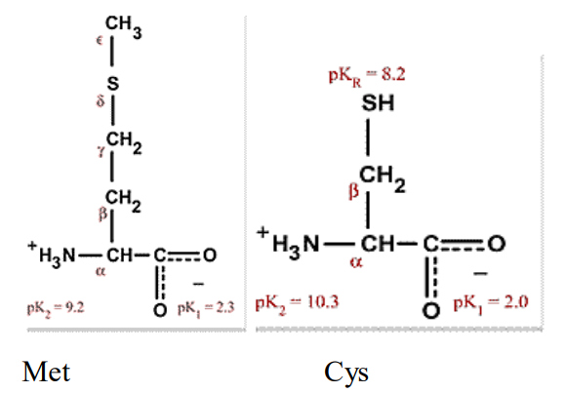

Sulphur-containing amino acids.

Figure. 1c: Structures of Amino Acids.

